Executive Summary
As of Week 13, RMN3 is currently performing in the bottom 20% or is at risk of falling into the bottom 20% across four key performance indicators identified in the Road to Benchmark (RTB) system (Appendix A). These metrics include UIS 5lb UPH, RC Sort Unknown Idle Time (UIT) %, Fluid Load (FL) Rate, and Manual Palletize (MP) Rate—all of which are critical to Sort and Transfer Out path performance. To address this, the PE team will conduct a Rapid Improvement Event (RIE) during Week 15. The event will be held in person, followed by structured weekly support through Week 18 to ensure the glidepaths are hit. All selected metrics were pulled from the RTB system, and based on current projections, RMN3 is on track to achieve above-average performance within the Gen 4.3 cluster by Week 19. The RIE will serve as a launching point for that trajectory.

RC Sort
Under the RC Sort umbrella, the following lifts are projected by Week 19 (Appendix B):
- UIS 5lb UPH: 664.01 to 720.
- RC Sort UIT %: 30.98% to 24%.
Unknown Idle Time flagging with UIS rate indicates disruptions in flow that are occurring on UIS. These disruptions can stem from several potential sources, including upstream jams, DICE-related or general freight management complications, inefficiencies related to the elimination of Decant, or Quality related obstacles. One of the primary objectives of this RIE will be to isolate the root causes of these barriers and create consistent rates for inductors within UIS.

Transfer Out
Within the Transfer Out bucket, the following lifts are projected by Week 19 (Appendix C):
- FL Rate: 63.27 to 100
- MP Rate: 61.65 to 72
Low rates on both fluid load and EOL suggest multiple barriers on OB dock operating in parallel. One potential action for fluid load could be to audit allocation plans and ensure that the plan recommended by Central Flow (optimized for pure loading and RWC utilization) is being adhered to. Additionally, if the root cause is determined to be overstaffing, headcount can be reallocated to improve the overall flow of the building.
Likely, there is some overstaffing occurring at Manual Palletize resulting in the rate flagging as bottom 20%. This will present an opportunity to reallocate elsewhere in improve the overall flow of the building.
Another potential opportunity for lift is presenting itself in low Inbound Blended CPLH (84.37 trailing 4-week average compared to 91.58 average for Gen 4.3 in Week 13), which suggests more than adequate inbound staffing. With the observed overstaffing on FL and MP, headcount can be reallocated to Outbound PIT and Outbound Waterspider to increase the total pallets loaded and therefore buffer churn on inbound dock. In addition to lowering FL and MP headcount with these moves, freight available for FL and MP should increase as inbound dock is able to turn its buffers and trailers more effectively. Additionally, tote availability for Transfer Out should improve as the RC Sort metrics above improve.

Next Steps
Pending approval of the plan and glidepaths indicated in this document, PE will reach out to RMN3 GM and Sr. Team to further diagnose root causes for performance in the four listed metrics and seek site alignment with the glidepaths. PE will be onsite for Week 15, debrief and prescribe actions at the conclusion of Week 15, and input prescribed actions into the applicable RTB projects. These actions will be tracked on through Week 19 in this quip to materialize the projected glidepaths.

Appendix
Appendix A: rIXD Gen 4.3 RTB Results Week 13: RC Sort UIT, 5lb Rate, FL Rate, and MP Rates.
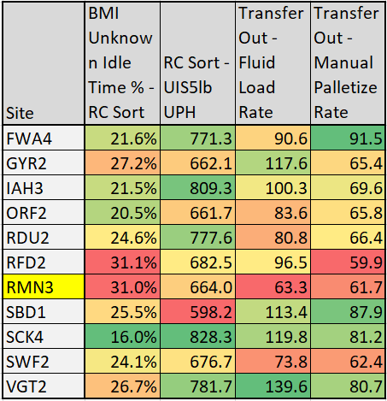
Appendix B: RMN3 RC Sort Glidepaths.
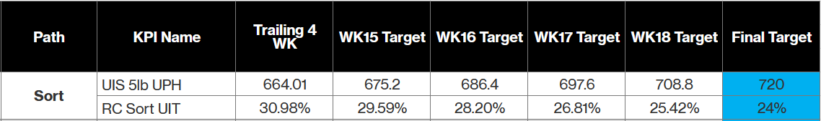
Appendix C: RMN3 Transfer Out Glidepaths.
